

Stationery List

Following is a list of the stationery requirements for your course. Please purchase these prior to your first day.

- Recommended that you bring your own laptop
- Two pens one blue and one black
- Pencil
- Pencil sharpener
- Eraser
- Highlighters
- Ruler (30cm)
- Basic Calculator
- Pencil case
- A4 refill pad or A4 Notebook
- A4 ring binder

At the start of year two the following textbooks are used during this course. You might find these books available at the library or possibly second-hand. Please try, where possible to get the edition (ED) mentioned below or a newer edition (rather than older one) of any textbooks you buy.

Compulsory Textbooks
Writing guidelines for Business Students (5th Ed) - Emerson; Cengage Learning
The Principles of Tourism (8th Ed) - Collier
Tourism A Modern Synthesis (4th Ed) – Page & Connell
Management 7 (7th or 11th Ed) - Robbins, Bergman, Stagg and Coulter; Pearson
Recommended Textbooks
Human Resource Management in New Zealand (5th Ed) - Rudman; Prentice Hall
Principles of Marketing (14th Ed) - Kotler & Armstrong; Pearson Prentice Hall

The compulsory textbooks mentioned above can be new or 2nd hand - new books are approximately $500 total for all four books. See below for suggested stockists:

Book depository: https://www.bookdepository.com/  Online (allow 3 weeks for delivery) | University Bookshop: www.ubsbooks.co.nz  Ph 306 2700
TradeMe:  www.trademe.co.nz  Mostly second-hand books | Abacus Educational Books: www.abacusbooks.co.nz  Ph 415 0630
ITC DRESS CODE
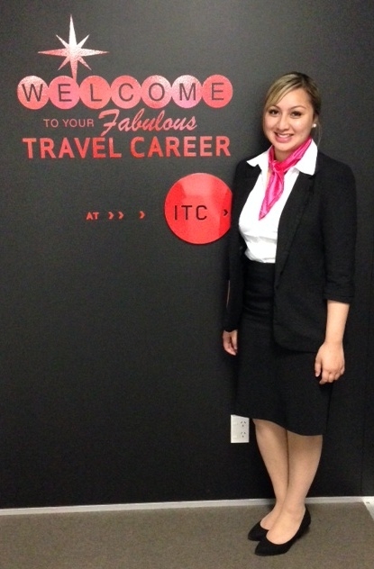
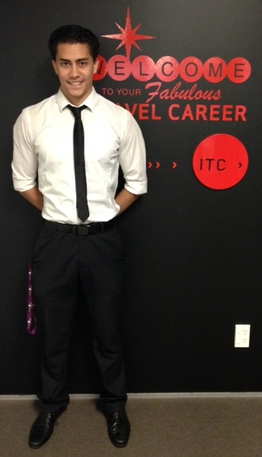

Great dress sense
=
Great opportunities

These are NOT appropriate

- Jeans
- Leggings
- Hoodies
- Sneakers
- Jandals
- T-shirts
- Hats
- Beanies

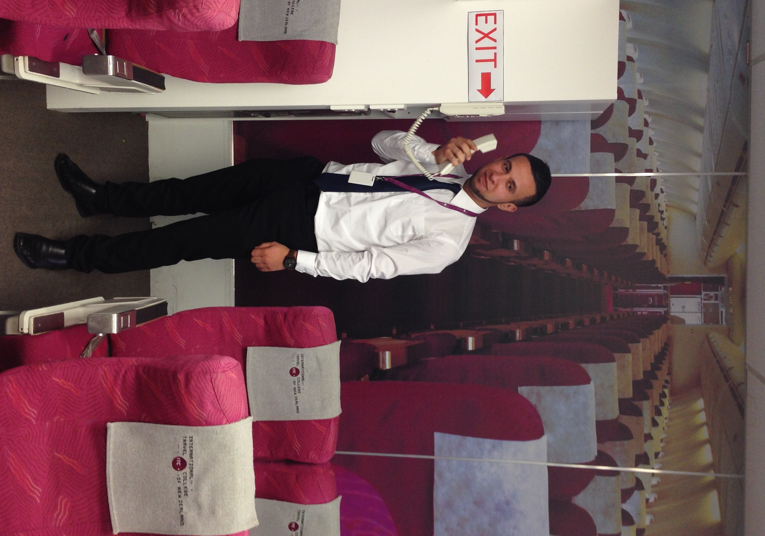
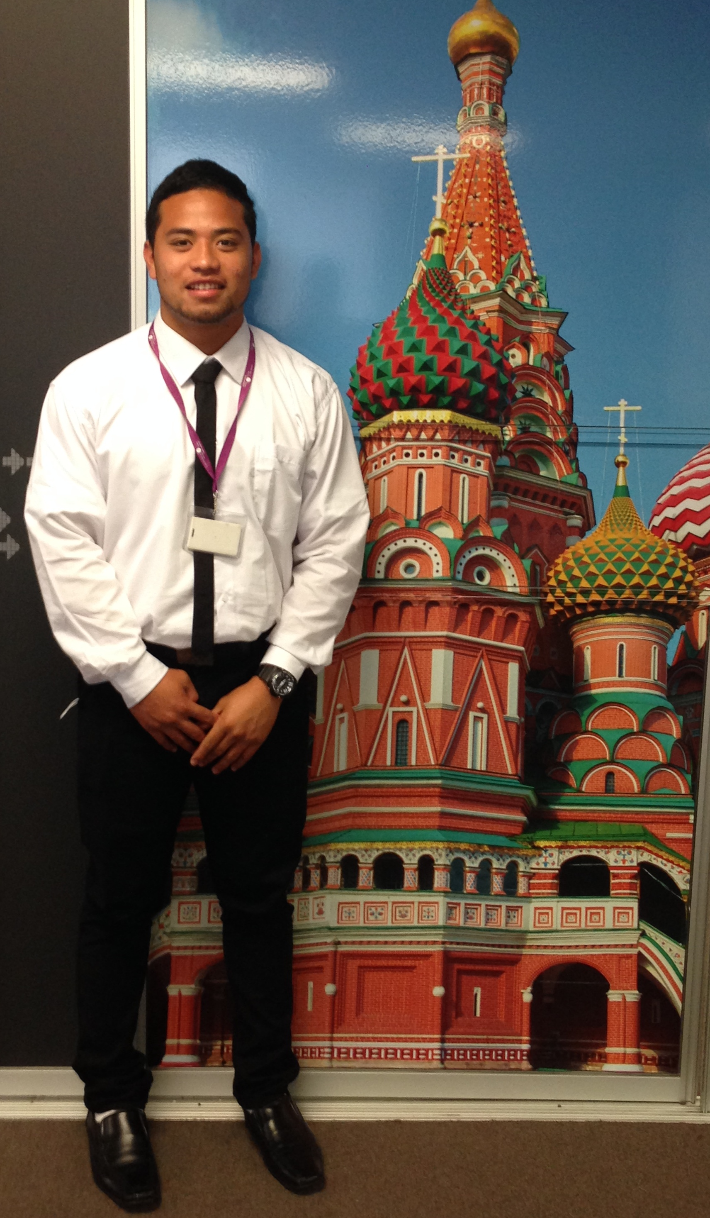
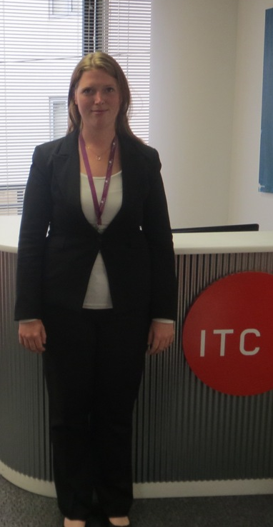

Why Business dress standards?
As a Business College training you for a career in the airline, travel and tourism industries, we operate a business dress standard. Industry employers visit the College on a frequent and regular basis and it is important for your future career prospects that you, and the College, project travel industry professionalism at all times.

What are Business dress standards?
The expectation is that students dress in black and white business wear at all times when attending the College. This is something that we always explain to students when they enrol onto our courses. The below will help you understand what Business dress looks like, and what you can and cannot wear.

 |  | Yes - Smart | No – Casual | 
 | Head | Headwear worn for religious reasons. | Hats, beanies, caps etc
 | Top half | White shirts, blouses, smart tops | T-shirts, tops with logos, denim jackets
 | Bottom half | Black trousers and skirts | Jeans, track pants, leggings
 | Feet | Black shoes | Jandals, bare feet, Ugg boots, slippers
 | Accessories | Simple jewellery | Sunglasses – too much bling!

If you are in any doubt about appropriate clothing please speak with a tutor or student services team member. They will be happy to advise you on this.

